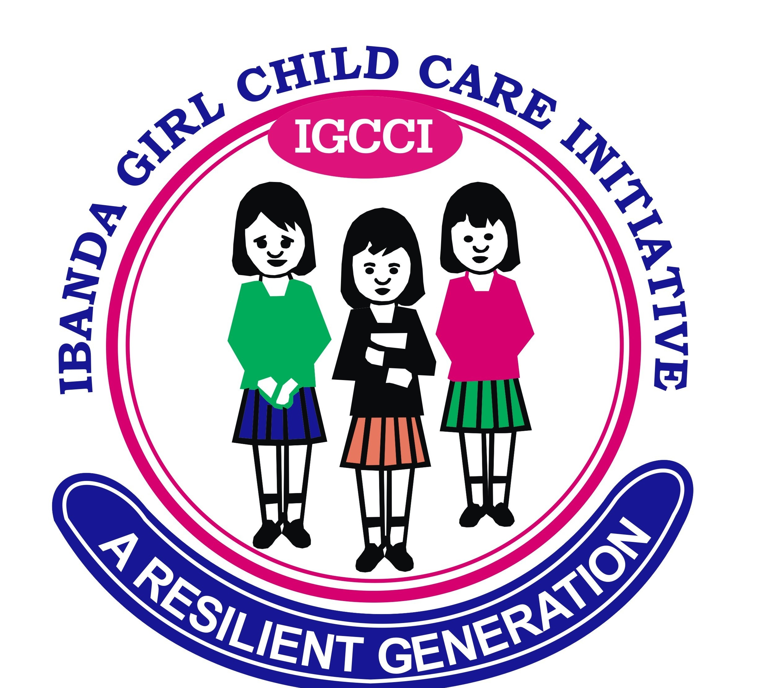

- Summary :

Name of the organization: IBANDA GIRL CHILD CARE INITIATIVE

Acronym: IGCCI

Type of organization: CBO

Founded in/on: July 22, 2020

Contact person Kasese-Uganda: Mughongo Edson

Telephone/Mobile phone: +256782496011
+256 758986261

E-mail: careforagirlchild04@gmail.com

Headquarters: Ibanda –Kyanya Rwenzori Region Kasese Uganda

Website: https://careforagirlchild.org

Thematic areas: 1. Food Security and Livelihoods
2. Education (Basic education & TVE)
3. Human rights and Protection
(Including GBV’s & SRHR)
4. WASH and Environment
5. Health and nutrition

Coverage area: Busongora North Kasese

II. Background
Having undergone one of Uganda’s most brutal civil wars for almost quarter a century in the Rwenzori region, Kasese still remains a fragile state bogged down with rampant violent extremism and Endless armed conflicts with its people are very much impoverished and remain highly Vulnerable.
Women and children in Kasese happen to be amongst the world’s most disadvantaged and underprivileged people and they are persistently exposed to a great deal of problems ranging from hunger, diseases, illiteracy, violence, deprivation of their fundamental rights, sexual amongst other abuses including human rights violations.

Kasese is a home for almost ¾ of the most marginalized, most miserable and most disadvantaged people in the entire Rwenzori Region because it is predominantly a home for
Uganda’s minority communities and the regions, severely affected by the long running surge
of civil war coupled with violent extremism and natural and manmade crises, are in Kasese district
Despite most of Kasese regions are rich in natural resources such as fertile arable land and rivers, a combination of protracted armed conflicts, recurrent droughts, and crop
Failures, flooding, damaged agriculture infrastructure and lack of labor opportunities result
in persistent food insecurity in every year eroding communities coping mechanisms and causing acute and chronic starvation, malnutrition, health and hygienic problems forcing communities to live below the poverty line.

As a result of the widespread impoverishment, many women and girl children are subjected to violence and exploitation including Child Early forced Marriage (CEFM), SGBVs, and child
labor particularly some families in desperate situations resort to living at the expense of their children leading to large numbers of children out of schools while many young girls
are married off just before their 18th birthday.

Amongst the fundamental rights of which particularly vulnerable and marginalized communities in Kasese are deprived is their right to basic services such as free primary education, primary healthcare service and access to nutritious food, clean safe drinking water and sanitation and this impelled women, children and other vulnerable groups to lead life at the receiving end of the country’s adverse plight.

III. Introduction

Ibanda Girl Child Care Initiative (IGCCI) is an independent, nongovernmental, non-profit and nonpolitical organization established to advocate for the protection of human rights, save and improve lives of most vulnerable, poorest and marginalized families affected by poverty and/or crisis, eradicate poverty and empower women and Girl children to reach their full potential.

IGCCI has been established in Kasese district, Ibanda-Kyanya Town council Deep Rwenzori region, on Friday December 20, 2020 with the purpose of protecting human rights, saving and improving lives ,building resiliency and creating lasting solution to hunger, extreme poverty, illiteracy and
Inequalities empowering women and children to reach their full potential
Since it has been established, CGC managed to partner with I4hnet,
AWCC has also become a strong network member of The Girl Generation, Women Thrive,
Care for a girl child (CGC) has its own clear cut written internal policies and procedures including financial, human resources and procurement policies with good accountability and project implementation capacity incorporated with community participatory approach.
Care for a girl child (CGC) has separate governance and management structures respectively comprising Board of Directors and Executive committees. For the Board of Directors (BOD) as the governing body of the CBO, their responsibilities include creation of CGC mission, purpose, direction and goals; develop policies and procedures on operations, fund raising, fiscal oversight and overseeing the strategic plan and performance of the entire organization.
For the Executive committee, it acts to implement CGC mission, strategic plan and board approved polices; attains goals set by the board, supervises staff and directs the entire day today business of the organization. Both committees (The BOD and the executive committee) have well defined separate and distinctive roles and responsibilities spelled out
in CGC charter/bylaws.

IV. Vision Statement

A sustainable world where all women and children of most vulnerable, marginalized and disadvantaged families have equal opportunities to survive and thrive

V. Mission Statement

Working with communities to advocate and protect human rights, save and improve lives of
Most vulnerable, poorest and marginalized families affected by poverty and/or crisis, and
Empower women and girl children to reach their full potential.

VI. Goal statement

The overall goal of Ibanda Girl child Care initiative (IGCCI) is to achieve lasting solutions to social injustices and disrupt the socioeconomic patterns that perpetuate negative effects on women, children and the marginalized people.

IGCCI Basic Principles of conduct:

- IGCCI believes in upholding its Constitution that clearly defines issues on membership, sources of funding, networking and more.
- IGCCI believes in self- help participation and identifying one’s potential
- IGCCI believes that every human being must live a good quality life
- IGCCI believes in strict accountability of all resources funds ,materials and time
- IGCCI works to unite staff towards achieving the mission by providing an attractive working environment and helping them in developing their careers and personal talents as well as security for employment.
- IGCCI works within government policies to achieve goals that effect the life of vulnerable children and out of school youth

X. Ownership, Governance and leadership
The policy frame work of IGCCI is guided by fully registered memorandum of and articles of association and regulated through the CBO board. In extending development supports to its clientele
IGCCI operates in organs which include:

- Executive Board :
Compared of (10) founder members and individuals invited on basis of adequate professional experiences in areas of relevance to IGCCI .They Include Board chairman, Treasurer ,and 7 Board members, the Executive Director is the secretary to the board .the board formulates policy and supervises implementation of programs.
- Secretariat :
The Head office is based in Ibanda- kyanya Town Council 5km from Kasese fort portal highway headed by the Executive Director .the secretariat is responsible for the day today implementation of policy and programs of IGCC. The Executive Director is supported by the program coordinator
- IGCCI Training centers:
IGCCI centers is where operational activities are curried out .the centers are headed by the project Coordinator assisted by the sectional head instructors and Trainers who train Vulnerable children and out of school youth in different skills offered by IGCCI. Two staff support them.

1.3 Program Focus and coverage

IGCCI `s geographical coverage is Kasese District, however Kasese District is engulfed by Busongora north ,Busongora South,Bukonzo West and Bukonzo East constituencies. These areas are reached by family tracing and resettlement, child advocacy and community outreach, sustainable farming and natural resources management, development training and research, formal, and non-formal education, HIV/AIDS and community health. IGCCI resettles children in other place hence other districts are reached by that process national wide.

The Direct beneficiaries of IGCCI programs are vulnerable children who are out –of-school youth and children who are working in hazardous conditions. IGCCI `s activities are preventive and Rehabilitative in nature .Hence, both approaches are used. A wide range of activities are undertaken by IGCCI.

    - Preventive activities: These include reaching out vulnerable children and out –of-school youth in their isolated areas, and through carryout counseling sessions, family tracing and community sensitization.
    - Community mobilization and the training on child and youth related issues as stipulated in UN convention on the right of the child and the Ugandan youth policy.
    - Training the out-of-school (vulnerable children, out-of-school youth) aged 15 and above, in vocational training and life skills.
    - Coordinating and supporting campaigns and actions on child and youth rights both national and community levels.
    - Active research and survey on specific issues affecting the out-of-school youth and children.
    - Publication on children /youth experiences.
    - Education support by paying fees and stationary for vulnerable children both at primary and secondary levels in the operational areas of IGCCI.
    - Empowering the girl-child and women youth groups in business management skills.

  - Rehabilitation Activities

These include mainly
    - Resettlement and re-integration of out-of-school youth and vulnerable children within the communities or their families before and after training.
    - Vocational skills training and life skills.
    - Post training and group formations for the trained youths.
    - Financials support to some of the trained youths start their own businesses/enterprises for self-sustenance.

2 .IGCCI`S DISTINCTIVES COMPETENCIES

IGCCI has excelled in the following areas and sufficient potential, skills, and experienced above. It has also developed personnel as well as other resources for their successes. These areas are: child frame recovery, counseling and resettlement, vocational training for disadvantaged children and youth, community mobilization and training and provision of sustainable credit to needy families to the resettled, reintegrated children and youth after training and rehabilitation

2.0 Funding

During the inception, the activities and programs were supported by grants contribution from founder members.
However, previous action have been supported by funding.
Organizations, IGCCI partners through provision of working materials and financial assistance to the designed programme activities (see the table below)

2.1 IGCCI sources of support (2020-2024)

Name of organization | year | Type of support
 | 2020-2021
Internet for humanity |  | Computers
She is the first | 2023&2024 | Leadership& rights
Fcde | 2020 update | Resource mobilization

N.B The above table shows both material and financial support extended to IGCCI to carry out its planned activities.

3. ACHIEVEMENT TO DATE

3.1 vocational skills training.

3.1.1 IGCCI has for established Vocational skill center for the out-of-school youth and vulnerable children both in Ibanda and kyanya town council. At these centers the following trades are offered:

- Carpentry and joinery
- Art and Design
- Weaving and knitting
- Tailoring and embroidery
- Catering
- Computer and secretarial training
- Non formal (literacy, numeracy and life skill)
So far 200 youth aged between 15 and 18 (Girls and boys) are benefiting from the programme each year

Special consideration are made to cater for education needs of the individual’s child. IGCCI divide its children in three categories i.e. (P.3-P.5andS.1-S.4 drop-out) those below 14 years are encouraged to go back to the basic formal education and the fees are paid and those between 15-18 years undertake vocational skills training.

IGCCI uses two language in instruction i.e. local and English to enable the trainers to pass on the skills also in other case, instruction charts and material are designed to facilitate the process. Life and coping skills are integrated in the training program.
Music as a media of also expressing one`s ideas is also incorporated in IGCCI`s program. Trade testing is carried out at LUGOGO training institutes which is a government testing institute to enable them get a recognized certificate.

3.2 advocacy & sensitization

IGCCI has managed to publish two books entitled, street children “why are they out”? And a guide book on “street children Rehabilitation process”. The IGCCI experiences and two research /surveys on child related issues have been conducted
- IGCCI has also strengthened its community based program and this is demand – driven .230 worked hopes and seminars have been conducted for a total of 3600 participants of which 70% were women and 30% men. Attitude of local leader (village), municipal council security personal, and media have at a certain extent been changed towards the vulnerable children .T .V and Radio discussion have been carried out.
3.3 school sponsorship

IGCCI has managed to sponsor 6 children in formal education (6 in primary section and 15 at senior secondary level). With the help of internet for humanity programme and other two students are supported by

3.4 Alliance Building & Partnership

Through networking both at local and international level numbers of a local and international volunteers have come, worked and share experiences with IGCCI, Notably volunteers from Quinoa Belgium, France America, University (internationally). Makerere Nsamizi training institute, Uganda catholic social training Centre ( local) and other local organization . IGCCI has been appointed as data .bank /information center for the intern go forum dealing with street children

We still need to network with all other organization / group /institute through exchange of experiences, material support, financial etc. For the benefit of our target group and group staff.

3.5 challenges

3.5.1 IGCCI still needs to get a long- term funder to support its strategic plan to fulfill its long term planned activities and program. With small grant from the above mentioned partners IGCCI has tried to reach –out to its target groups, as indicated above . There is need to strengthen its funds raising programme both locally and internationally to sustainably manage its planned activities /programs.
3.5.2inadequte funding has hampered its development plan (having a sustainable and equipped center) . These is need to strengthen and diversify the funding to pay staff to facilities the planned activities with motivated staff.
This in the past has hampered the implementation of planned activities as many look for better opportunities elsewhere in the NGO sector.
3.5.3 Empowering the trained youths with equipment and material or loans is still a problem
3.5.4 There is need to strengthen this area to have a successful story of the rehabilitation children and youth.

4. ADDRESS

